Ben Thompson
CS 2450
10/26/2025
Final Project – Planning Stage
- Project Description:
My project will solve the issue of trying to keep track of all of the grocery items that you have so that you can keep track of where they are located along with when it needs to be bought again at the store. Users will include everyone that has a house and needs to keep track of all their groceries and household products. The system will easily keep track of all household goods, their quantity, and stored location so that users can remember when to buy new products and know where they are stored so that they can stay organized. This will make sure that products aren’t overbought.
- Requirements and User Scenarios:
My system will keep track of all the household goods that a user input into the system and display them in a table like format so that the user can view them and make the necessary plans. Users will be able to add new items, update/edit items, and delete items.
As a user, I want the capability to add new items to my list of items, to keep track of them.
As a user, I want the capability to edit my existing items in my list, so that when I buy new items or use them up, I can change that in my list.
As a user, I want the capability to delete my items from my list, so that once I use up and item or decide not to buy it anymore it can be removed.
As a user, I want the capability to login to the system, so that my items can be tracked and kept.
As a moderator, I want the capability to edit user accounts and data, so that error can be corrected across all accounts.

- Use Case Diagram:
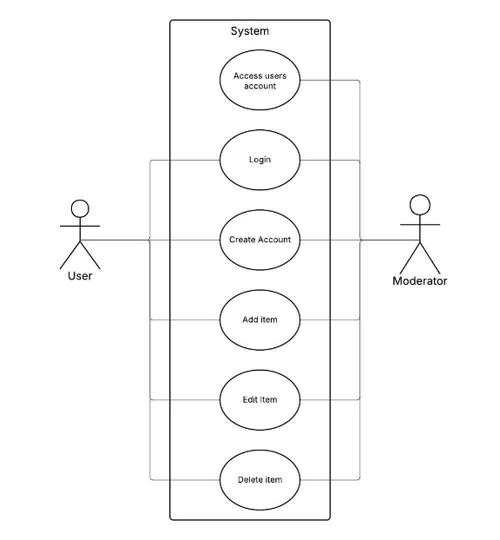
- Domain Model:
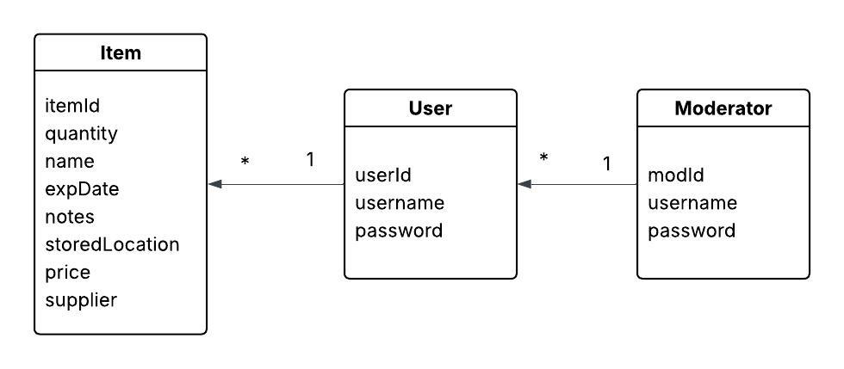

- Wireframes:
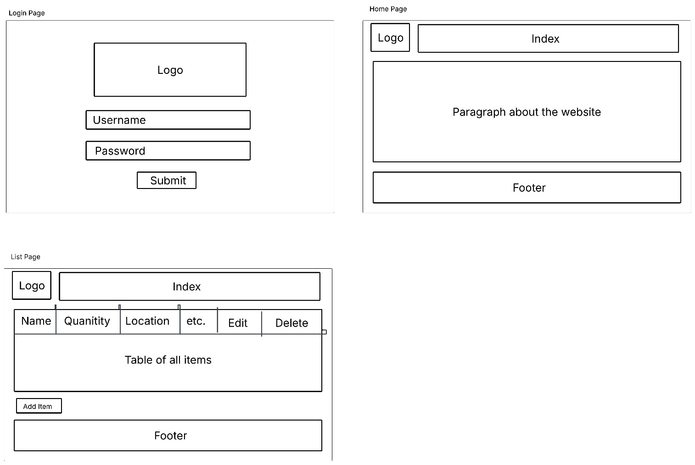

- Login Page – the purpose is to allow users to sign in and access their lists of items.
- Home page – the purpose is to give users brief information and ability to go to their lists
- List Page – the purpose of this page is to allow the users to view, add, edit, and delete items.

